ECE 49022 – Team 02 (Multi-FX Guitar Pedal) – Reverb Pedal – Michael Scirocco

1. Schematic:

1. (Please see attached Gerber files)
2. PCB:

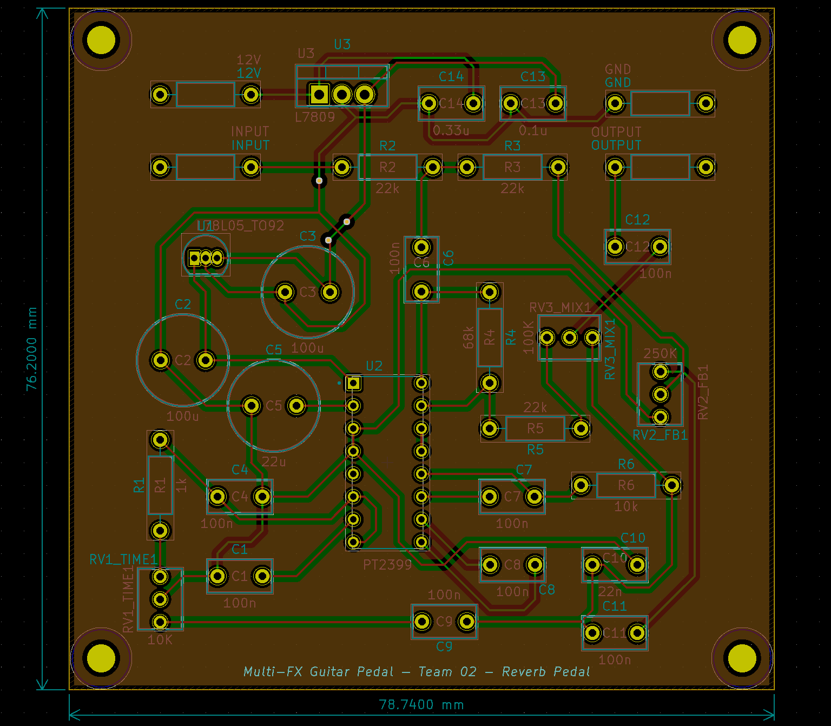

1. Proof of DRC/ERC checks:Graphical user interface, text, application

   Description automatically generated

ERC Comments: The first two errors are the schematic not recognizing the +12V symbol as a power source. The third error is for a pin that does not need to be connected.

1. Centroid file: N/A, we are soldering the components in ourselves.
2. Printout of planned order from manufacturer’s website:

1. Complete and final bill of materials (BOM):

* Resistors:
  + 1kOhm – 1x
  + 10kOhm – 1x
  + 22kOhm – 3x
  + 68kOhm – 1x
* Capacitors:
  + 100n – 8x
  + 100u – 2x
  + 22u – 1x
  + 22n – 1x
  + 0.1u – 1x
  + 0.33u – 1x
* Potentiometers:
  + 10k – 1x
  + 250k – 1x
  + 100k – 1x
* Other:
  + 78L05 (3-Terminal Voltage Regulator) – 1x
  + L7809 (Linear Voltage Regulator) – 1x
  + PT2399 (CMOS Echo/Delay Processor) – 1x

1. Responses to rubric questions:

What manufacturer do you plan to use: PCBWay

What is the lead + shipping time: 8 business days

What quantity do you intend to order: 5  
Manufacturer specifications

Maximum number of layers: 10

Surface finish: HASL with lead

Copper weight: 1 oz Cu

Minimum solder mask clearance: 0 mm

Minimum drill hole size: 0.2 mm

Minimum trace width: 0.1mm/4mil

Minimum trace spacing: 0.1mm/4mil

Minimum via to trace spacing: 0.15 mm

Blind / Buried vias: both Yes / No

Have you configured your tools DRC based on these specifications: Yes / No

Does your PCB require a stencil to populate: Yes / No

If so, do you have a plan to order one: Yes / No

All components fit on PCB printed 1:1 scale: Yes / No

Checked for and corrected issues from appendix 1 checklist: Yes / No

Your team name and number is clearly visible in the silkscreen: Yes / No